Marton Manor Primary School
Design and Technology Policy
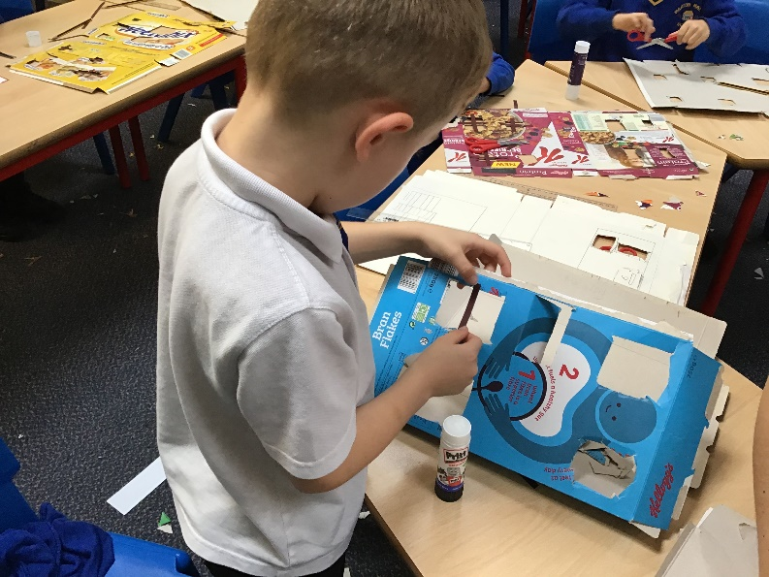

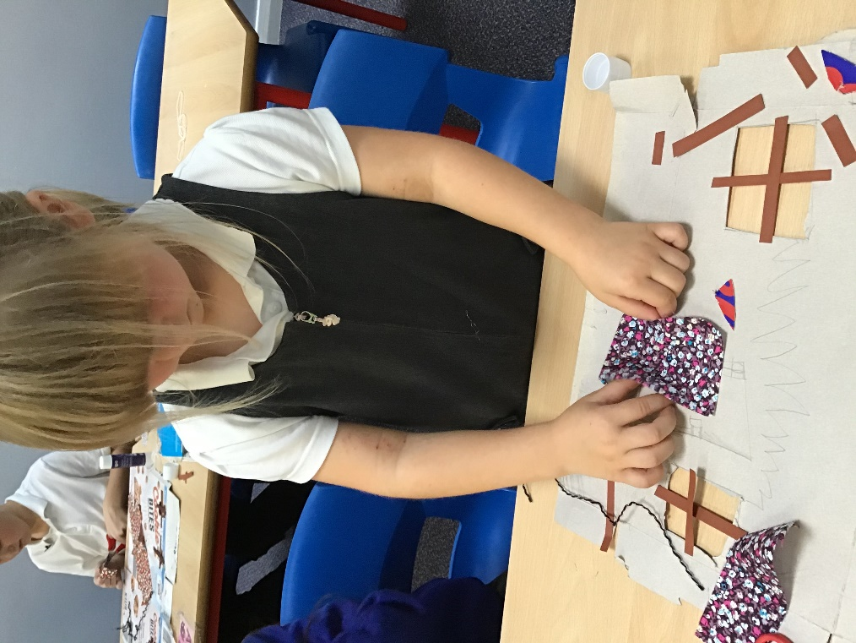

The purpose of the Design and Technology policy
This policy outlines the teaching and learning of design and technology at Marton Manor Primary School. All children will have the opportunity to undertake design and technology throughout their time at Marton Manor Primary School. This policy was formulated in consultation with staff and governors at Marton Manor Primary School in Summer 2020. It was approved by Governors in Summer 2020 and will be reviewed in Summer 2023 or earlier if necessary.

Aims
Design and technology is a practical subject.
- We aim to prepare pupils to participate in tomorrow’s rapidly changing
technologies.
- To provide opportunities for all the children to design and make quality products.
- To provide children with the opportunity to explore food and cooking techniques along with healthy eating and environmental issues within food production.
- To develop design and making skills, knowledge and understanding to the best of each child’s ability; using and selecting a range of tool, materials and components.
- To become creative problem solvers as individuals and members of a team.
- To be able to use computing in conjunction with the Designing and Making process.
- To develop an ability to criticise constructively and evaluate their own products
and those of others.
- To help the children develop an understanding of the ways people in the past and present have used design to meet their needs. To reflect on and evaluate such techniques, its uses and effects.
- To prepare the children for living in a multi-cultural society by teaching consideration for other culture which will be both important and beneficial.

Objectives
To achieve our aims we ensure that the planned activities our children undertake are challenging, motivating, relevant and enjoyable. We give children confidence in their work by providing continual support and encouragement. The children are extended in their work in a way which develops their expertise. The children are provided with the very best resources possible, while constantly reviewing this provision in the light of curriculum review, development and links with other subjects.
Curriculum and school organisation
We use a skills and knowledge based cross-curricular approach to teaching and learning using objectives taken from the National Curriculum. We teach DT skills discretely and through our Curriculum themes, ensuring all children access all areas of the Design Technology Curriculum.
In Early Years Foundation Stage, Design and Technology is an integral part of topic work, relating aspects of the children’s work to the objectives set out in the Early Learning Goals, and Expressive Arts and Design. To facilitate our objectives different teaching styles and methods are used as appropriate. These include small group and individual work.
To meet the requirements of the National Curriculum it is essential that each teacher carry out the following Design Technology activities within a year;
- Mechanisms
- Textiles
- Food
- Structures
Design and technology curriculum planning
Design and technology is a foundation subject in the National Curriculum. Our school uses both the National Curriculum and our own curriculum map as the basis for its curriculum planning in design and technology.
Our medium-term plans, which we have adopted from the National Curriculum give details of each unit of work for each term. They identify learning objectives and outcomes for each unit, and ensure an appropriate balance and distribution of work across each term.

Personal, social and health education (PSHE)and citizenship
Design and technology contributes to the teaching of personal, social and health education and citizenship. We encourage the children to develop a sense of responsibility in following safe procedures when making things. They also learn about health and healthy diets. Their work encourages them to be responsible and to set targets to meet deadlines, and they also learn through their understanding of personal hygiene, how to prevent disease from spreading when working with food.

Spiritual, moral, social and cultural development
The teaching of design and technology offers opportunities to support the social development of our children through the way we expect them to work with each other in lessons. Our groupings allow children to discuss their ideas and feelings about their own work and the work of others. Through their collaborative and co-operative work across a range of activities and experiences in design and technology, the children develop respect for the abilities of other children and a better understanding of themselves. They also develop a respect for the environment, for their own health and safety and for that of others. They develop their cultural awareness and understanding, and they learn to appreciate the value of differences and similarities. A variety of experiences teaches them to appreciate that all people are equally important, and that the needs of individuals are not the same as the needs of groups.

Assessment
Assessing a child’s performance is a continuous process carried out over the full seven years of Primary school and our assessing methods include the following as appropriate:-
1. Looking at a child’s recorded work i.e. model, photographs, written work.
2. Individual discussion.
3. Listening to the children’s ideas as they discuss between themselves.
4. Group discussions in both planning and reporting back sessions.
5. Observing the children’s skills in Design and Technology.
6. Record the progress that children make by assessing the children's work against the learning objectives for their lessons. At the end of a unit of work, teachers make a judgement against the Key Learning Skills.

Recording
It is essential that the type of recording be matched to the type of Design and Technology activity as well as to the needs and abilities of the child. A variety of recording methods are therefore used. These include pictures, structured worksheets, sketches, diagrams, flow charts, model making, written explanations, photographs, school displays and on occasion video recording.

Resources
Our school has a wide range of resources to support the teaching of design and technology across the school. Classrooms have a range of basic resources, with the more specialised equipment being kept in the design and technology store.
This includes the safe storage of tools such as glue guns and hammers.

Safety in Design and Technology
The safety of the children is the responsibility of the class teacher. The children are made aware of the safe use and correct procedure involved when using tools and equipment in a learning environment and how to follow proper procedures for food safety and hygiene.
The children are made aware of the need to be careful and to understand that their actions can affect others.
The children build up a range of skills when using equipment to reduce unnecessary risk. Craft knives are used only by 5/6 under direct supervision of an adult. Glue guns are used (low temperature) under supervision. All staff, including helpers, are made aware of food safety procedures when working with food to minimise any risks. The children wear protective clothing if necessary.

Monitoring and review
The monitoring of the standards of children's work and of the quality of teaching in design and technology is the responsibility of the design and technology subject leader. The work of the subject leader also involves supporting colleagues in the teaching of design and technology, being informed about current developments in the subject, and providing a strategic lead and direction for the subject in the school. The design and technology subject leader gives the head teacher and governors an annual report in which she evaluates the strengths and weaknesses in the subject and indicates areas for further improvement. The design and technology subject leader has specially-allocated, some management time in order to review evidence of the children's work and undertake lesson observations of design and technology teaching across the school.

