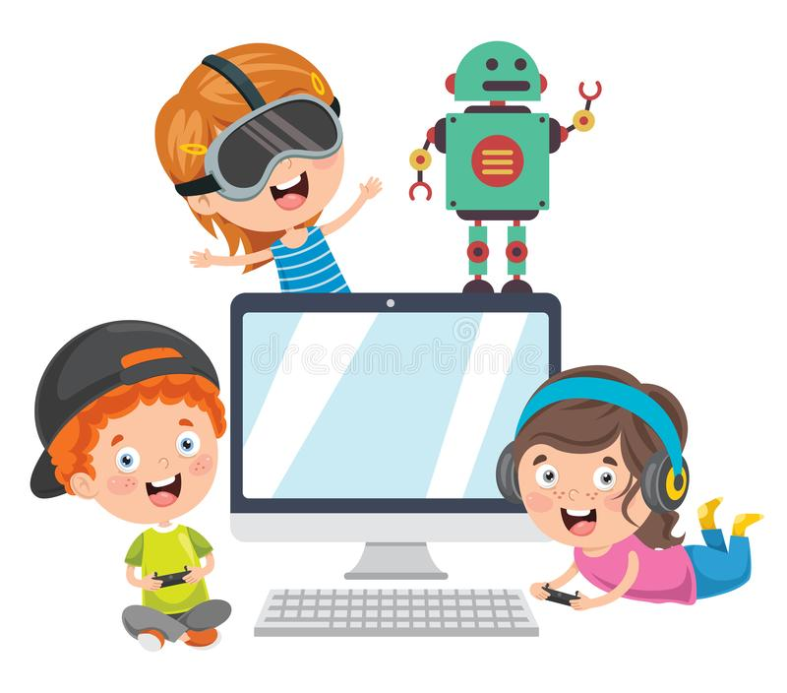

Curriculum Rationale
2020

Curriculum Rationale

Computing is split into 3 main areas: computer science, digital literacy and information technology. In each year group, before any other teaching can begin, children should be taught about the importance of e-safety which comes under digital literacy. This may include safe searches, cyber bullying, email attachments, personal information, and knowing if information is reliable and / or trustworthy. Children will learn how to recognise any of these and how to respond if something bad happens. E-safety modules are to be taught first and foremost so that children can recall this information from previous years’ teaching and build on it before they learn another area. During the remainder of the modules, children will need to be aware of any e-safety implications for each and every lesson where appropriate. During the year, children will complete at least 2 modules of computer science which means using an additional scheme of work available on the school network. This is to ensure that the logical reasoning side of computing is consolidated at least once as children have had less exposure to this area. It also means that children do not only use Purple Mash Coding software, they also use Scratch to understand the process of writing algorithms, particularly as code becomes more complex as they move through school. They should be taught to understand the meaning of coding blocks by analysing existing algorithms and predicting what will happen. They should be resilient so that when something does not happen as expected they can work out why. They should be able to create their own programs based on their own designs as opposed to copying down examples with no understanding of what it means. Children also need to learn about how to use a range of software for different purposes. Children should understand that there is more to a computer than word processing; they should learn about spreadsheets, databases, data handling and graphics programs. They should be able to use a combination of software to solve a problem by using the programs’ import and export functions.

Children begin their journey in computing by being exposed to a range of technology in foundation stage. This can be touch screens, keyboards, mice, sound and video recorders and programmable toys. This forms the basis for Key Stage 1 where children may be given a simple username and password. They understand basic algorithms for everyday activities and are beginning to write their own. They may use apps on an iPad to input basic algorithms. In lower Key Stage 2, children are more confident at using their own computer and will be taught how to make their own programs where a sprite on a computer can be interacted with. As they move through Key stage 2 they are introduced to more complex terminology that will help them to create more interactive programs. This may include, If, Repeat, When, and the use of Variables. They will continue to combine software and in Year 5 and 6 they may combine DT with Computing to create a functional piece of equipment or prototype for a larger project.

