WELCOME
I am delighted to take this opportunity to welcome you as a parent of a new child attending Marton Manor Primary School. Starting school is an exciting and challenging time for you and your child. New pupils soon settle down to the activities and work of the school. It is our aim to make both children and parents feel comfortable and at ease in our school. The staff are all dedicated professionals and will be happy to answer your questions should you have any. We have a genuine policy of encouraging all parents to come and discuss how, together, we can help your child to gain success and maximise opportunities at school.
I hope this booklet will answer many of your questions but if you have any others then please feel free to contact us and we will do our best to help.

Gerri Howard
(Head Teacher)

KEY ADDRESSES AND TELEPHONE NUMBERS

School Website www.martonmanorprimary.co.uk

Marton Manor Primary School
The Derby
Marton
MIDDLESBROUGH Telephone: 01642 285001
TS7 8RH Fax: 01642 285002
Children, Families and Learning Department
Middlesbrough Borough Council
2nd Floor
Vancouver House
PO Box 69
MIDDLESBROUGH
TS1 1EL Telephone: 01642 245432

South Tees Community & Mental Health
West Lane
Acklam Road
MIDDLESBROUGH Telephone: 01642 813144

School Nurse,
School Health
West Lane Hospital
West Lane MIDDLESBROUGH Telephone: 01642 316678
Chair of Governors
Mrs Jean Sharrocks
c/o Marton Manor Primary School
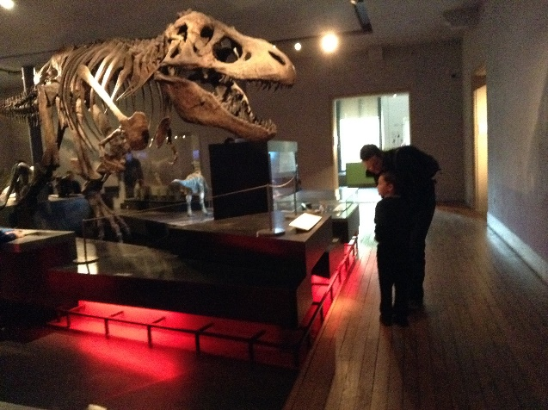

MEMBERS OF THE GOVERNING BODY OF
MARTON MANOR PRIMARY SCHOOL
Chair of Governors Mrs Jean Sharrocks
Parent Governors .
Mrs K. Frazer Mrs K. Arnold

Teacher Governor Mrs K. Blades Staff Governor Mrs S. Hayes

Community Governors Mr A. Illingworth Mr B. Murphy

STAFF
Head Teacher Mrs G Howard
Deputy Head Teacher Mrs D Docherty
Teaching staff Miss S. Williams Nursery
Miss G. Mc Poland Reception

Mrs C. Hardisty, Mrs Ogden, Mrs L. Chapman, Mrs S. Smith, Mr M. Homer, Miss R. Watson, Mrs R. McDonald, Mrs K. Blades Special Educational Needs Co-ordinator

Teaching Assistants Mrs L. Field Mrs S. Baggett Miss H. Russell Mrs P. Burdess Mrs S. Tye Mrs B. Lockwood Mrs S. Hayes Mrs P. Marshall Mrs E. Bainbridge Mrs C. Michiels
Miss B. Crosby Mrs A. Cockshott Mrs N. Graham

Administrator Mrs L. Hallett. Miss H. Kaur
Caretaker Mr D Readman Cook Mrs S. Metcalfe

French teacher key stage 2 Mrs H. Sayer

Lunchtime staff Mrs A.M. Pollard, Mr R. Turnbull, Mrs S. Hayes, , Mrs J. Robinson, Mrs C. Brook, Mrs C. Michiels Mrs M. Bennett and Mrs L. Allen

After- School Staff Mrs B. Francis Mrs S. Hayes Mrs C. Michiels

SCHOOL INFORMATION
Marton Manor is an all age primary school for boys and girls between the ages of 3 and 11 years.

SCHOOL ROLL
The school roll for the academic year is expected to be 202 from September plus approximately 52 Nursery children by the end of the academic year. We have planned places for 30 pupils in each year group. Priority is given to children within our local catchment area and then beyond if space permits. The Local Authority publishes its Admissions criteria annually and we adhere to these. When places are at a premium priority is given to pupils who are Looked After and children with special needs are also given consideration. Sibling links are also part of the criteria and then children who are in closest proximity to the school.

SCHOOL BUILDINGS
The school has a 26 place part time Nursery which enables us to provide half day nursery education for 3 and 4 year old children. Children become eligible for a nursery place (subject to a place being available) on or after their third birthday.

ADMISSION TO SCHOOL
In September all children who are eligible for Reception class places transfer from the Nursery into school in one phase. Children who are born between 1 September and 31st August come into school full-time in the Autumn Term, in the school year in which they are five years old. If there are not enough places for the Nursery children (i.e. in excess of 30) then places are allocated first to children within our catchment and then those who meet eligibility criteria most closely. Parents who still wish to have a place may go appeal to the local authority.

PRE-SCHOOL PREPARATION
Starting school is a major step in your child's life. It is the start of your child's independent life and you can help to prepare your child in many ways:

Encourage your child to put on and take off his/her own clothes - especially
their school PE clothes. Ensure that your child is used to wearing their school
clothes. Encourage your child to mix with other children and adults so that they develop social skills and feel at ease.
Encourage your child to do simple tasks around the home, e.g. set the table, tidy
their toys, put their clean clothes away, help you sort the washing.
Make sure that your child can go to the toilet and wash their hands without adult
help.
Please ensure that they can use a knife and fork.
Spend a small amount of time each day reading with your child. Encourage them
to choose a story and discuss it with you. This helps to extend and develop a
child’s vocabulary. It also helps them to develop their listening skills and
concentration powers and other language skills.
Encourage your child to write in any form, this is the foundation of literacy.
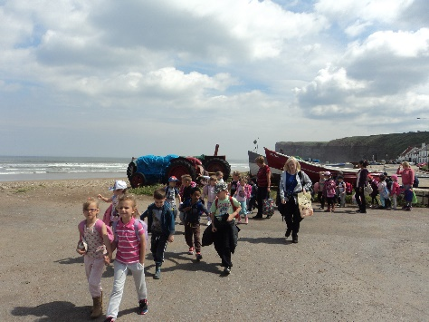

VISITS BY PARENTS
We usually arrange formal parents’ visits each term when you will have the opportunity of seeing your child’s work and talking to the teacher. These evenings are very well supported. The children look forward to their parents seeing their work. We feel it is very important for the children to understand that home and school are working together in the important process of their education.

However, concerns may arise at other times of the year, and we would be grateful if you would let us know as soon as possible if anything is worrying you or your child. In this way we can try to prevent minor concerns becoming major problems. Class teachers are usually available for a short time before or after school, although it may be necessary to make an appointment if you need a bit longer to talk. The Head Teacher is happy to speak to parents, but a telephone call to arrange an appointment would be appreciated, to organise a mutually convenient time to meet.

Reports are sent out in the early part of Summer Term for all of the children. A portfolio of children’s work is built up over the year and is available for parents to see. Information is passed on to secondary schools when children transfer.

SMOKING
All Middlesbrough schools and Council premises are non-smoking establishments and this includes the school grounds and car parks. No pupil, parents, staff, contractors or visitors may smoke at any time on these premises. This includes electronic cigarettes. Smoking is not permitted when staff or parents accompany children on educational visits.

TEACHING ORGANISATION
Children are mainly grouped according to age.
The school is organised in three teaching teams:
Foundation Stage-Nursery & Reception
Key Stage 1-Year 1 &Year 2
Key Stage 2-Year 3 to Year 6

Children are taught in the educational setting which best suits their own or the classes needs on a lesson to lesson basis. This may involve the child being taught individually, in a small group or as a member of their whole class.

SCHOOL YEAR GROUPS
Nursery : 3 year old onwards
Reception (R) : 5 years old before 31 August
Year 1 (Y1) : 6 years old before 31 August
Year 2 (Y2) : 7 years old before 31 August
Year 3 (Y3) : 8 years old before 31 August
Year 4 (Y4) : 9 years old before 31 August
Year 5 (Y5) : 10 years old before 31 August
Year 6 (Y6) : 11 years old before 31 August

PASTORAL CARE
The care given to children is of the highest priority in our school. Children are the responsibility of their class teacher and the teaching assistant who may be working with the class. However, all staff are aware of the need to be responsible for the health, safety and well-being of all pupils around school as appropriate.

BEFORE AND AFTER SCHOOL CARE
The school operates a facility for children to be cared for any weekday before or after school.
Times: Morning from 8 a.m. until the start of the school day at 8.50 a.m.
Afternoons from 3.15 until 5.30 p.m. The charges for this service are very competitively priced because we know that childcare is costly and we want to provide a service to working parents. A price list and forms are available from the school office. If you wish to use this facility we need some prior notice so that we have contact information and details of any medical information needed for the staff. Parents are asked to book children in online and pay online so that we can ensure we have the correct staffing ratio.
.

BEHAVIOUR AND DISCIPLINE
We believe that the best form of discipline is self-discipline and the development of
this is seen as a paramount aim of the school. We have our Golden Rules which the children help to write up and these are shown on photographs in every classroom. Pupils are generally required to conduct themselves in an orderly manner at all times and remain on the school grounds during normal school hours.

Our school has a comprehensive Behaviour Policy which was agreed with staff, children, parents and governors. This is available for reference on request. We encourage proper care of all school property and equipment. Courtesy and respect are important for adults and children alike.

ATTENDANCE
To assist us in maintaining a high standard of care and education for your child we would ask that for any absence a reason is given to our office staff. If your child is ill please telephone the school on the first morning of the absence as early as possible and by the latest 9.15 a.m. If we do not hear from you we will contact you to ensure that your child is at home safe with you. All such calls are logged by the school's Administrator, Mrs Hallet

The school day begins at 8.50 am and we are very eager to ensure that children are punctual for school. We do note children who arrive late and if a pattern of lateness begins to emerge then parents will be contacted and asked to improve the situation.

We positively discourage parents from taking holidays in school time. If this is unavoidable then parents should request a holiday form. Holidays in term time may only be approved in exceptional circumstances. The local authority may issue a fine if a holiday is taken and is unauthorised. Parents should consider taking children during one of the other school holidays if they cannot have time off during the summer break. These guidelines allow us to monitor absence very closely.

When collecting your child for appointments please notify Mrs Hallett or Miss Kaur in the school office in order that we can mark children as being off the school premises in case of a fire, etc.

EMERGENCY PROCEDURES
If your child is ill or has an accident at school it may be necessary for us to contact you. If your child has to be taken to hospital they will not give certain treatments to a child unless a parent or guardian is present. It is essential, therefore, that we have your telephone number for home and business in case of emergency. If you are not on the telephone, then a telephone number of a close relative or neighbour, or some other means of rapid contact should be arranged.

MEDICINES
We have always tried to help parents by being willing to administer medicines to children in school time. However, with an increasing number of children taking medicines, this is causing problems, eg safe storage of medicines, etc. We have a few children on long term medication who take medicines for most of the year, but it would be a great help to us if children who are on short term medication, eg a course of antibiotics or cough mixture, could be given their medication at home.

If it is impossible for a parent to administer the medicine at home the following conditions must be strictly observed. This applies to all children, even the oldest. Medicines must be clearly marked:
- with the child’s first name and surname
- with the name of the medicine
- with the required dose and how often it should be taken.
These items must be handed to the school’s Administrator in the school office and collected by an adult at home time. Medicines can only be dispensed by First Aiders. We also have a consent form which needs to be filled in before we can administer medication. Please see the school’s Administrator in the school office. If your child is asthmatic, diabetic, epileptic or suffers from peanut allergy or other allergies, the school should be informed immediately.

MEDICAL AND DENTAL SERVICES
The school nurse makes visits to the school and will get in touch with parents when necessary. If your child has any ailments or disabilities which might affect his/her work, health or safety at school, please let us know about it. Special diets, problems relating to ears, eyes, heart, etc are all examples of information which teachers may need to know about. These should be noted on the information sheet.

SCHOOL DINNERS
Our cook prepares and serves each day a selection of hot main courses with a choice of vegetables and two or three puddings. A healthy salad bar also operates with a wide selection of foods that will appeal to most. We can provide information about this Dinner money SHOULD BE PAID ONLINE AND DETAILS OF HOW TO DO THIS CAN BE OBTAINED AT THE SCHOOL OFFICE. or the first day your child attends school each week, in the sealed envelopes provided. If you wish to pay by cheque please make payment to “JCLT” If you wish to you may pay in advance for your child’s meals for a half term or a term. A commitment for a half term to whatever form of lunches you choose is required. If you wish to change your lunch arrangements at the beginning of a new year please advise Mrs Hallet the school's Administrator, in writing. Parents are welcome to sample a school lunch before their child starts full time education. Please let Mrs Hallet know in advance if you wish to do so. The Nursery staff will advise you of the day that this will take place and the cost.

FREE SCHOOL MEALS
A free school meal is supplied to children in Key stage one and Reception However, it would help us to secure funding from Pupil Premium if parents could make us aware if they think their child would have qualified for a free school meal under the former system (i.e. the parent is in receipt of specified benefits or income supplements).

Children in key stage two whose parents are in receipt of Income Support or Universal Credit may also be eligible for free school meals. If you think your key stage two child may be entitled to free meals, please contact the school or the Revenue and Benefits Section, 2nd Floor, Middlesbrough House, Corporation Rd. Middlesbrough. Every effort is made to ensure that children receiving a free school meal cannot be distinguished from other children.

ROAD SAFETY
To ensure safety I would ask for your co-operation in not parking directly outside the school as this is dangerous for small children. A lead given by parents in practical road safety would be a valuable lesson to the children. Also we would be grateful if parents did not walk across the car park when bringing children to and from school. Parents should not park their cars in the school car park when bringing or dropping children off at school. Parents can use the bus lay –by near the school as a dropping off and picking up point. We are always concerned about the potential danger to children from reversing cars and delivery lorries. Please park considerately and refrain from blocking the school entrance.

SCHOOL UNIFORM
The general policy of Marton Manor Primary School is to encourage pride in appearance, neat and tasteful dress habits and the avoidance of extremes of fashion. In the interests of health and safety and security we would ask that your child does not wear jewellery in school. With this in mind we recommend the following:
Girls
Grey skirt, school kilt/ pinafore or grey trousers
White shirt or blouse
Royal blue sweater/sweatshirt, fleece or cardigan

Boys
Grey trousers
White shirt/long sleeved shirt
Royal blue sweater/sweatshirt or fleece.

Uniforms - Ordering
Items can be ordered via school by completing an order form available from outside Mrs Hallet’s office. Forms are to be found in the transparent document wallets on the wall. Our supplier (Lollipops) will put the school logo on sweatshirts and cardigans along with your child’s initials provided this is made clear on the forms.

PE
Yellow T-shirt, royal blue shorts, gym shoes (not trainers).Special uniform is available from our sweatshirt supplier and these are very reasonably priced with children’s initials where requested. Blue track suits are useful for winter months.

SHOES
We would prefer that children wear proper shoes rather than trainers as this causes some problems with changing for PE. Denim clothing, tracksuits and fashion clothing are more expensive and less suitable than those listed above and we would prefer that these were not worn for school.

We would also ask that children do not adopt outrageous hairstyles which are not considered appropriate for a school environment.

ALL ITEMS OF CLOTHING SHOULD BE CLEARLY MARKED WITH YOUR CHILD'S NAME.

THE SCHOOL CURRICULUM
At Marton Manor we teach a broad and balanced curriculum, offering challenges appropriate to the age and ability of each individual child. We provide a wide range of learning experiences covering the programmes of Study for all National Curriculum subjects. Detailed planning and assessment by teachers provides practice and enrichment. This ensures progression at the optimum rate for each child.

Children are encouraged to relate and co-operate with others in the process of learning. Staff promote purposeful teaching and learning situations where children can imagine, question, problem-solve, hypothesise, evaluate and record. In this way we hope to develop lively and enquiring minds.

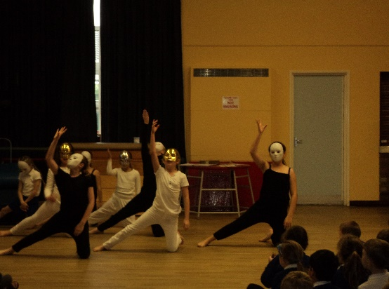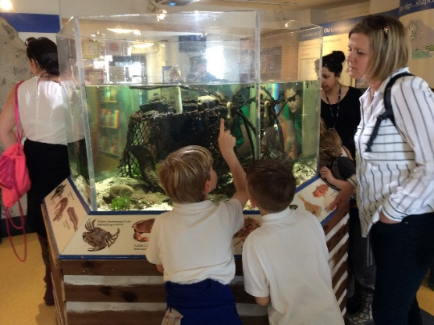

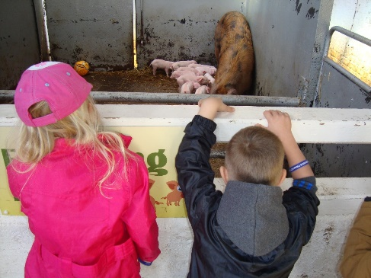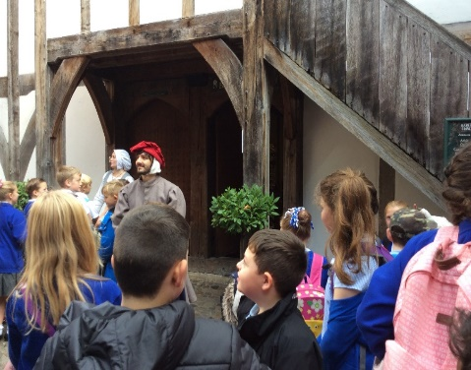

HOMEWORK
A copy of our Homework Policy is available on request. Pupils are usually given homework two or three times a week. Parents will be notified at the start of the school year about which nights to expect homework and this may take the form of written work, interviewing people, reading, testing out an idea or research in books or on the internet if this is available. A homework diary is provided from Year 2 so that parents can give feedback about the child’s work and whether they found it an appropriate challenge. This is designed to encourage the children to achieve some independence and self-organisation.

SPORTING PROVISION AT MARTON MANOR PRIMARY
Children are encouraged to take part in a number of sporting activities during curriculum time. Sports coaching is provided for children by qualified coaches on a weekly basis at specific times of the year after school. Our overriding aims are to develop individual skill levels, foster the need for teamwork, encourage after school participation if children show an interest and celebrate sporting achievements both in and out of school.
EXTENDED SCHOOLS
Many sporting events and arts clubs are organised out of school hours. This includes choir, art, cookery, dance, football, cricket, tennis, netball, rounders, tag rugby and cross-country etc… Some of these operate on a seasonal basis and we try to offer something to every age group during the year. Pupils also have the opportunity of having a residential experience as part of our outdoor education and adventurous activities when they are in key stage two.

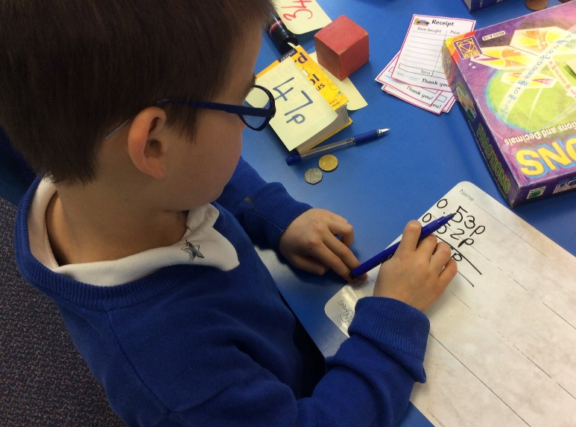

VISITS AND CHARGING POLICY
All children have opportunities to take part in educational visits in connection with their school work. We normally ask parents to make voluntary contributions towards the cost of these outings. There is, however, no obligation to contribute. No pupil in the group will be omitted from the visit but often a substantial number of contributions need to be made if the visit is to take place.

SPECIAL NEEDS AND DISABILITY
The school provides a curriculum for children of all abilities. However, from time to time children are identified in various ways as having a special need. We have a senior member of staff who is designated Special Needs Co-ordinator (SENCO) who is responsible for the liaison within the Psychological Service, Learning Support Service and Behaviour Support Service, after consultation with the Head Teacher and parents.

The first approach to addressing the needs of a child are examined within the school by means of providing a 'normal' school curriculum. It is possible however, that individuals may have special educational needs that are significantly greater than the majority of children of their age. Children are monitored by their class teacher as a general assessment procedure. Staff are trained to ensure the Head Teacher or Special Educational Needs Co-ordinator are informed of any concerns they may have. Parents are kept fully informed if we have cause for concern. Mrs Blades is our school's Special Educational Needs Co-ordinator. The school has recently reviewed its policy on Special Educational Needs and Disability in line with LA guidance and the 1993 Education Act. This is available for inspection.

Some of our pupils have particular special educational needs for which they receive additional teaching assistant support. The school is also proud of its inclusion policy which seeks to ensure that these children are integrated into the life of the school as fully as possible. The school also has a policy for more able and talented pupils which helps us to ensure that work is matched to the individual’s ability level. Their progress is carefully monitored to ensure that they are suitably challenged and fulfilling their true potential.

TRANSFER TO SECONDARY SCHOOL
The Council operates a system of parental preference. Every parent will receive a copy of the authority's publication, "Secondary Education in Middlesbrough". The Governing Body adheres to the Council Curriculum Policy Statement. Most children in the immediate area transfer to King’s Academy, and a small number choose Nunthorpe or Stokesley Secondary schools. There are still catchment zones operating, but other criteria are also used to help decide on school allocations. The Education Department can give advice on these issues.

STATEMENT REGARDING THE EDUCATION REFORM ACT (COMPLAINTS ABOUT THE SCHOOL CURRICULUM AND OTHER RELATED MATTERS)
The Local Education Authority has established a procedure for considering complaints from parents relating to the school curriculum, the charging and remissions policies of schools, religious education and collective worship. It is hoped that parents would raise any concern they might have about such matters with the Head Teacher in the first instance. If parents wish to make a formal complaint, details of the procedures available can be obtained from the Head Teacher or from the Local Authority.

COMPLAINTS PROCEDURE (See Complaints Policy/procedure)
In the event of a complaint about any other matter relating to the school, parents are asked to bring this to the attention of the child’s class teacher in the first instance. If the parent feels that the matter has not been resolved an appointment may be made to speak to the Head Teacher. Failure to reach a satisfactory outcome may mean that parents will wish to pursue the matter with the Chair of Governors, by sending a sealed envelope to the school marked for their attention. Where a matter is not resolved to the parent’s satisfaction it may then be pursued with a panel of Governors. This is all explained in our Trust Complaints Procedure.

Parents may obtain paper copies of policies on request from the Head Teacher. A charge will be made for photocopying. A list of policies is available on the school website.

CHANGES
The information in this school prospectus was prepared and published in September 2020, relates to the 2020/21 school year and was correct at the time of going to press.

It must not be assumed that there will be no changes affecting the relevant arrangements or certain matters before the start of, or during, the 2020/21school year or in respect of subsequent school years, arising for example, from variations in Government or Local Authority policies for Education.
And finally, thank you for taking the time to read our school prospectus. 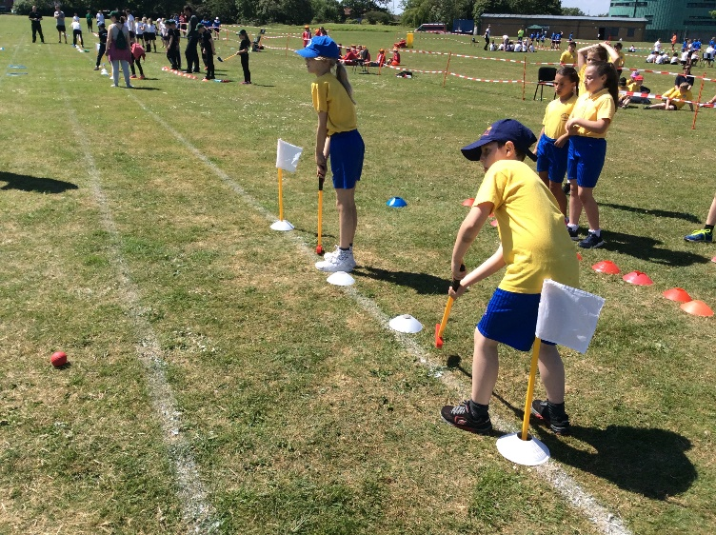
You will be sure of a warm welcome in school at all times.

