Supporting Transition into Year 3
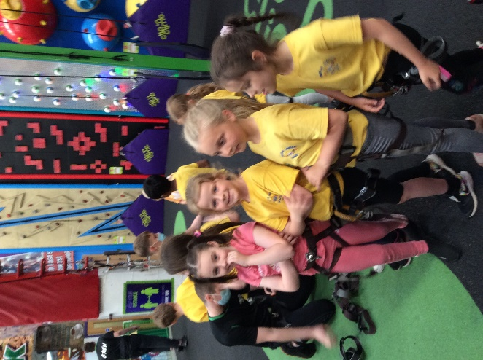
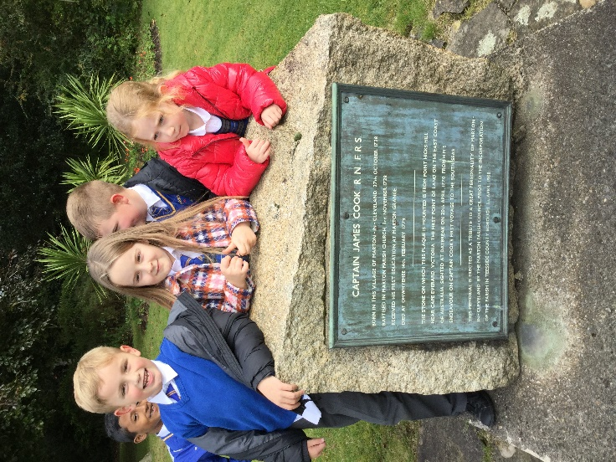
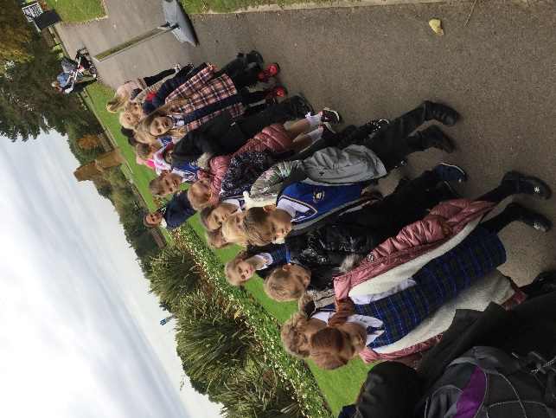

Welcome to Year 3!
We have an exciting year ahead, filled with incredible learning opportunities, adventures and interesting challenges.

Personal goals will guide our learning and behaviours in Year 3, whilst aiming for a personal best in everything we undertake.

Reading, Writing and Mathematics are key subjects that the children will continue to learn. Through a progressive learning curriculum, the children will develop rich knowledge and understanding in R.E, Science, Geography, History, Art and Design Technology, French, Computing, Music and PE.

Mr McQuade,
Year 3 Teacher

Throughout the year, students will hopefully be involved in a variety of activities designed to explore their creativity, resilience and perseverance, and challenge them in new and dynamic ways such as themed learning days and school trips.

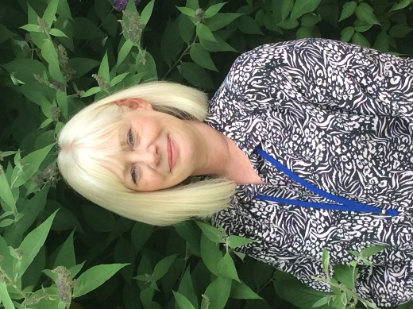

It is our priority to ensure that each and every student feels happy, confident and engaged in their learning, so as to reach their full potential both academically and socially. To achieve this, we believe that a strong partnership between the teachers, the parents and the students is integral.

It is going to be an exciting year and we are really happy to have you joining us for the journey.

Mrs L Field,
Year 6 Teaching Assistant

MATHEMATICS IN YEAR 3

ADDITION & SUBTRACTION | NUMBER & PLACE VALUE | Fractions, Decimals & Percentages | MULTIPLICATION & DIVISION | MEASURES | GEOMOETTRY | STATISTICS
I can use different methods to mentally add numbers with up to 3 digits.  I can use different methods to mentally subtract numbers with up to 3 digits.  I can add numbers with up to three digits, using formal written methods, including regrouping.  I can subtract numbers with up to three digits, using formal written methods, including exchanging.  I can solve one-step + and - problems, including missing number and missing symbol problems. | I can read and write numbers up to 1000 in numerals and in words.  I can compare and order numbers up to 1000.  I can count in steps of 50 and 100.  I can find 10 or 100 more or less than a given number.  I can partition numbers into H T O using different combinations.  I can solve number problems involving place value to three digits. | I can count up and down in tenths.  I can recognise, find and write fractions of a discrete set of objects.  I can recognise, using diagrams, equivalent fractions.  I can add and subtract fractions with the same denominator within one whole.  I can compare and order fractions, including those with the same denominator.  I can solve problems that involve all of the above. | I can recall multiplication facts for the 3, 4, 6 and 8 multiplication tables.  I can recall division facts for the 3, 4, 6 and 8 multiplication tables.  I can use more formal methods to begin multiplying 2 digit numbers by a 1 digit number.  I can solve problems using x and ÷ facts, including missing number and missing symbol problems.  I can work out simple division sums with remainders. | I can read a range of scales involving different units of measure.  I can solve problems involving measures.  I can add and subtract amounts of money to give change, using both £ and p in practical contexts.  I can tell and write the time to the nearest 5 minutes on an analogue clock, including Roman numerals from I to XII.  I can measure the perimeter of simple 2-D shapes. | I can name 2D and 3D shapes and describe their properties.  I can identify right angles, recognise that two right angles make a half-turn, three make three quarters of a turn and four a complete turn.  I can identify whether angles are greater than or less than a right angle.  I can identify horizontal and vertical lines and pairs of perpendicular and parallel lines. | I can interpret data presented in bar charts, pictograms and tables.  I can solve one-step and two-step questions presented in bar charts, pictograms and tables.

ENGLISH IN YEAR 3

Grammar | Punctuation | Spelling | Reading | Writing
I can use a or an according to whether the next word begins with a consonant or vowel.  I can use conjunctions, prepositions and adverbs to express time, place and cause;  I can use both past and perfect form of verbs e.g. He went out; He has gone out; | I can use inverted commas to punctuate speech mostly correctly.  I can use capital letters . ! ? correctly in most of my sentences.  I can use commas in lists.  I can use apostrophes for a wider range of contraction words.  I can use apostrophes for singular possession. | I can spell most of the Year 1/2 key words and some of the Y3/4 words, correctly in my writing.  I can use and apply taught spelling rules in my writing.  Prefixes dis~, mis~, re~, in~, il~, im~, sub~, auto~, anti~, ir~, inter~, super~  Suffixes ~ally, ~ing, ~ed, ~er, ~tion, ~sion, ~ation.  Homophones  · ai / a_e – pail, pale;  · ee / ea – meet, meat;  · 3 way homophones:  there / their / they’re  buy / by / bye  heal / heel / he’ll  · i / y – die / dye  · i_e / igh – side / sighed  · oa / ow – groan / grown  y sounding i – mystery  ou sounds  shout, young, tour  ow u oo  ei, eigh, ey sounding a  vein, eight, obey | I can read age appropriate texts mostly fluently and accurately.  I can use different strategies to read longer unfamiliar words.  I can take note of punctuation when reading aloud and use some expression.  I can read root words with prefixes/suffixes added and understand that this changes the meaning.  I can read and match words with similar meaning.  I can summarise some of the main events/information from within a piece of text.  I can ask questions to check my understanding of words/information within a text.  I can use skimming and scanning to retrieve information from texts, most accurately.  I can make simple reasoned inferences linked to a character’s actions, feelings, thoughts and motives.  I can make predictions about a text based on what I have read so far. | I can write narrative that has a clear beginning, middle and end.  I can write narrative with character and setting descriptions.  I can write non-narrative that includes information organised into different sections and appropriate language and grammar.  I can use key genre features in order to write for different purposes.  I can write sustained pieces independently, that include paragraphs.  I can use a wide range of adjectives to add detail and further expand my noun phrases.  I can use verb tense, person and subject/verb agreement mostly correctly.  I can use a joined/cursive script with clear ascenders and descenders that are legible.  I can edit my writing to correct mistakes, some of which I have found myself.

SCHOOL HOURS
Your child should be at school promptly to organise their school bags have a few minutes to greet their friends and prepare themselves for learning.
In Year 3, students participate in learning activities as soon as the school day begins so it is therefore imperative that they are punctual. If children arrive at school after their start time, please ensure that they come to the Main Office to be registered before joining their class. Please remember that punctuality encourages a positive attitude and really helps your child's progress.
All children should be collected by an adult unless you have told the school otherwise.

 | Start of day |  |  | Home time
N AM | 8.30 | Front gate (EYFS door) | N AM | 11:30 | Front gate (EYFS door)
N PM | 12:30 |  | N PM | 3:30
Reception | 8.50 | Front gate (EYFS playground) | Reception | 3.15 | Front gate (EYFS playground)
Y1 | 8.45 | Front gate (Y1 door) | Y1 | 3.10 | Front gate (Y1 door)
Y2 | 8.40 | KS1 yard (KS1 door) | Y2 | 3.05 | KS1 yard (KS1 door)
Y3 | 8.45 | KS2 yard (KS2 door) | Y3 | 3.10 | KS2 yard (KS2 door)
Y4 | 8.45 | KS1 yard (Y4 door) | Y4 | 3.10 | KS1 yard (Y4 door)
Y5 | 8.40 | KS2 yard (Y5 door) | Y5 | 3.05 | KS2 yard (Y5 door)
Y6 | 8.40 | KS2 yard (KS2 door) | Y6 | 3.05 | KS2 yard (KS2 door)
S.B. | 8.50 | Front gate (Front entrance) | S.B. | 3.15 | Front gate (Front entrance)
Holidays
We are unable to authorise holidays during term time. If your child is genuinely ill, you must ring the school office to inform us of your child’s absence. Only the headteacher can approve illness: you may be asked for medical evidence.

UNIFORM
Details about the correct school uniform requirements are set out on the school website. Click www.martonmanorprimary.co.uk/school-uniform/
Please remember to label everything including shoes, coats, hats and gloves and show your child where the label is. Shoulder length or longer hair should be tied up and this should be in hair accessories only in the school colours.
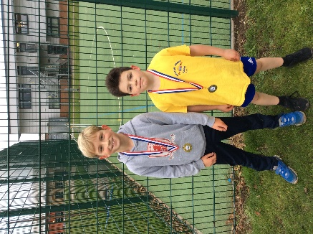
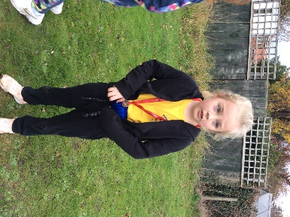
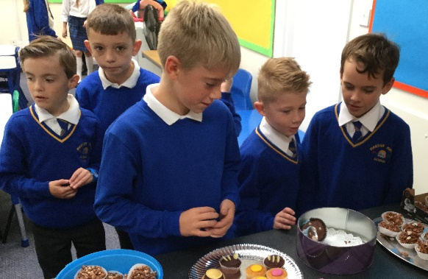
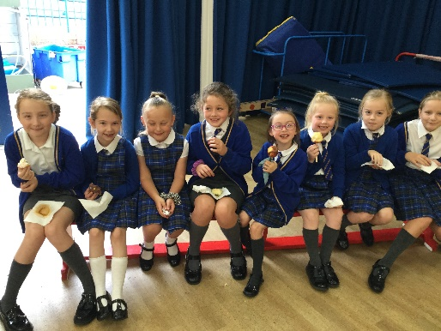

PE KIT
Correct uniform must be worn for physical education sessions. Students should bring their P.E. kit at the beginning of each week and take it home at the end of the week for cleaning. Details about the correct school uniform requirements are set out on the school website. Additionally, children are welcome to wear tracksuits, sweatshirts and jogging bottoms when P.E. is taking place outside, especially during late Autumn/ early Spring.
EQUIPMENT
The School provides students with pencils, crayons, books and stationery. Parents are asked to provide: A named school bag which fits on a hook/peg. Students should be encouraged to be responsible for their own belongings and to pack their own school bag. They must bring their reading book to school every day. Please ensure all items are clearly labelled.

COMMUNICATION
We use 4 platforms to communicate with our parent community:

School Website: Our school website contains information regarding important dates, events and special days relating to our school.
School Gateway: This online communication tool can be used to pay for KS2 school d inners or educational visits your child may take part in during their time at Marton Manor.

Social Media: At Marton Manor we use both Twitter and Facebook to regularly update our parents and wider community about special events, trips and experiences that our children receive during t heir time here.

Text Messages: We will send a text message to relay important information about cancellation of clubs, important events and reminders. Make sure the school office have your up to date contact details.

PARENT TEACHER MEETINGS
Parents are encouraged to make appointments with the teachers to discuss any concerns as they arise. In addition to the ongoing contact with class teachers that we encourage, we have a number of formalised times for parents and teachers to discuss progress and set targets.
There are two parents’ evenings throughout the year. A written report will also be sent to parents during the Summer term.
Should you have any concerns, do not hesitate to contact your child's class teacher to make an appointment at a convenient time. mryear3@martonmanorprimary.co.uk

